Full Stack Lab MST
Question 1:
Code:
<!DOCTYPE html>
<html>
<head>
<title>Post Form</title>
</head>

<body>

<h2>Create Post</h2>

<form id="postForm">
Title:<br>
<input type="text" id="title" required><br><br>

Body:<br>
<textarea id="body" required></textarea><br><br>

<button type="submit">Submit</button>
</form>

<p id="message"></p>

<script>

document.getElementById("postForm").addEventListener("submit", function(e){

e.preventDefault();

let title = document.getElementById("title").value;
let body = document.getElementById("body").value;

fetch("https://jsonplaceholder.typicode.com/posts", {

method: "POST",

headers:{
"Content-Type":"application/json"
},

body: JSON.stringify({
title: title,
body: body
})

})

.then(response => response.json())
.then(data => {
document.getElementById("message").innerText = "Data submitted successfully!";
console.log(data);
})

.catch(error => console.log(error));

});

</script>

</body>
</html>

Output:
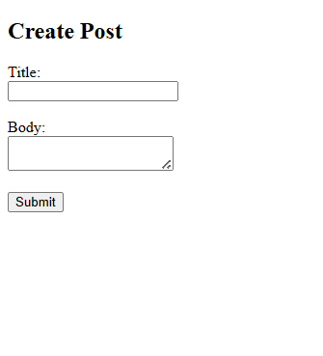

Question 3:
Code:
<!DOCTYPE html>
<html>
<head>
<title>DOM Manipulation</title>
</head>

<body>

<p id="text">Click the button to change this text</p>

<button onclick="changeContent()">Click Me</button>

<script>

function changeContent(){

let para = document.getElementById("text");

para.textContent = "Welcome to JavaScript DOM Manipulation";

para.style.color = "blue";

para.style.fontSize = "24px";

}

</script>

</body>
</html>
Output:
